Christine Brown
Acceleration Lab
Purpose: To measure the acceleration of a dropped book.
Materials: TI-84, Motion Detector, Ring stand, Physics Book.
Procedure:
- Set-up ring stand.
- Attach the motion detector to the ring stand.
- Plug the motion detector into the TI-84.
- Turn on both devices.
- Run the LoggerPro application.
- Hold the book under the motion detector and release quickly when a buzzing noise is heard.
- Make a graph using the LoggerPro application.
The independent variable in this experiment was how quickly the book was dropped.
Data:
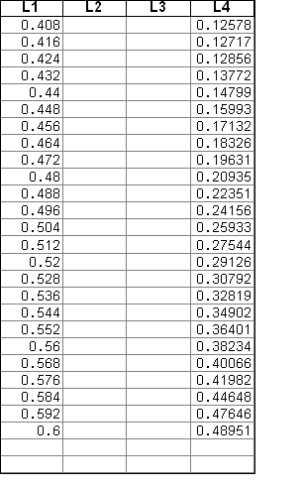

Data Analysis:
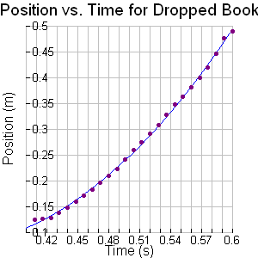

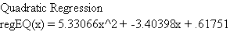
1st Derivative= 10.66132x + -3.40398
2nd Derivative=10.66132
Acceleration= 10.66132m/s²

Conclusion:
The acceleration of the dropped book was found to be 10.66132 m/s². Acceleration due to gravity is 9.8m/s². The book could not have fallen faster than gravity was pulling on it. Some source of error could include that the motion detector was not calibrated before use, the book was not held close enough to the motion detector.

